ABOUT SCHEDULE SPEAKERS CONTACT REGISTER NOW

High-growth technology
business conference Asia edition (Bangkok) 2023

Hosted by LES Thailand
in collaboration with the European Patent Office
with support from LES Italy and LES Singapore
2 - 3 November 2023 In-person

REGISTER NOW at Contact@licensingthailand.com

LES Member Non-LES Member*
THB 1,500 THB 5,000

Group rate is available

* For Non-LES Members who register, they will be able to sign up for LES TH membership at a discounted rate

Sponsored by
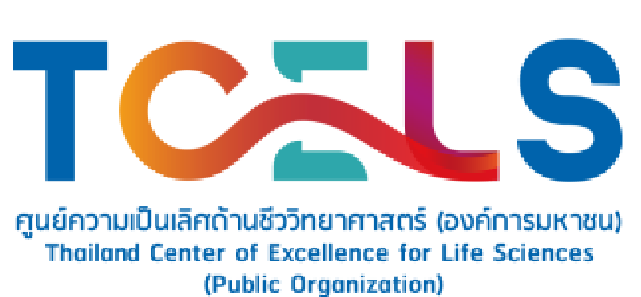
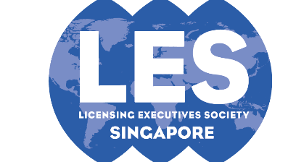

Proudly supported by

Be part of The Growth
10+
Organisations
10+
Networking hours
15+
Speakers
80
In-person

Mark Your Calendars Now! 2 - 3 November 2023
WHERE
Grande Centre Point Terminal 21
2 Sukhumvit Soi 19 (Wattana), Sukhumvit Road, Klongtoey Nua, Wattana, Bangkok 10110, Thailand

WHEN
Thursday and Friday
November 2 - 3, 2023

00 : 00 : 00 : 00

Days Hours Mins Secs

REGISTER NOW
About High-growth technology business conference
Asia edition (Bangkok) 2023

BUSINESS AND INTELLECTUAL PROPERTY NETWORKING

In-person networking with an international list of Business Owners, IP professionals, Research Institutions and Government representatives

Learn more

BUSINESS AND INTELLECTUAL PROPERTY WORKSHOP

A dual track of Business and Intellectual Property workshops will be conducted by distinguished and experienced trainers

Learn more

BUSINESS AND INTELLECTUAL PROPERTY SESSION

A full day of sessions focusing on the importance of IP in business support. An international team of experienced practitioners will share best practices on IP-related topics from a business decision-maker and an IP specialist perspective
Learn more

Come Listen to Leading Experts From Around The World
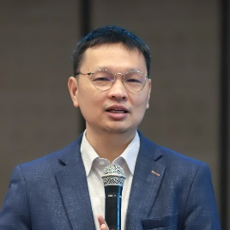
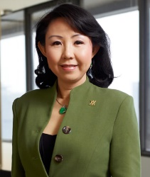

Juergen Graner
Founder and CEO, Globalator (USA, UK, Austria)

David Ai
Head of Innovation Research and Innovation, London School of Economics

Audrey Yap
Past President LESI, Managing Director, Yusarn Audrey LLC

Apiwat Thongprasert Managing Director, VISUP

VIEW ALL SPEAKERS

High-growth technology
business conference Asia edition (Bangkok) 2023
BUSINESS CONFERENCE TOPICS

- Technology Businesses Powered by Brands
- Turning Technology into Financial Assets
- Focus on Your Users for Your High Growth Tech Business
- Make Open Innovation Work
- Manufacturing Trends and IP Strategies
- The Importance of Licensing to Foster Innovation
- IP Commercialization - Case Study
- Chat GPT: Disruptive or the Future? / AI / Digital Lending
- Transaction Based Growth Management
- Trade Secret Management
- Valuation of IP

AGENDA OVERVIEW

GET YOUR TICKETS TO
HIGH-GROWTH TECHNOLOGY
BUSINESS CONFERENCE ASIA EDITION (BANGKOK) 2023
2 - 3 November 2023 In-person
EMAIL US

Contact@licensingthailand.com
REGISTER
NOW

WHERE?

Grande Centre Point Terminal 21
2 Sukhumvit Soi 19 (Wattana), Sukhumvit Road, Klongtoey Nua, Wattana, Bangkok 10110, Thailand

REGISTRATION FEE

Registration Package | Member Rate (THB)  (Per Person) | Non-Member Rate (THB)  (Per Person)
Package A (1 Seat) | 1,500 | 5,000
Package B (5 Seats up) | N/A | 3,500

PAYMENT METHODS
Wire transfer to account information below:
Account Name: Licensing Executives Society (Thailand)
Account Number: 020-109544-1
Bank Name: Kasikorn Bank PCL
Address: 716/5 Techavanit Road, Bang Sue, Bangkok 10800 THAILAND
Swift code: KSITHBK

For more information or to RSVP, please contact Ms. Sireethorn Somjade
at th@yusarn.com or +66 (0) 22341585-88
We hope you will be able to join us.

